**3D Locomotion of a Snake-like Robot Controlled by**

**Cyclic Inhibitory CPG Model**

Zhenli Lu1*,*2*,*4 Shugen Ma1*,*3 Bin Li1 Yuechao Wang1  
  
„  
*B. Mutual Inhibitory CPG Model*

According to the mutual inhibitory theory, we adopt the

above SANs to form a CPG, as shown in Fig.3a. This mutual

inhibitory CPG is composed of *ne* (extensor neuron) and *nf*

(flexor neuron). The dynamics of the mutual inhibitory CPG

is described by the following equations:

*Tn,eu*˙*e* + *ue* = *s*0*,e − ag*(*uf* ) (3)

*Tn,fu*˙*f* + *uf* = *s*0*,f − ag*(*ue*) (4)

*y{e,f}* = *g*(*u{e,f}*)*, g*(*u{e,f}*) = *max*(0*, u{e,f}*) (5)

*c out* = *ye − yf* (6)  
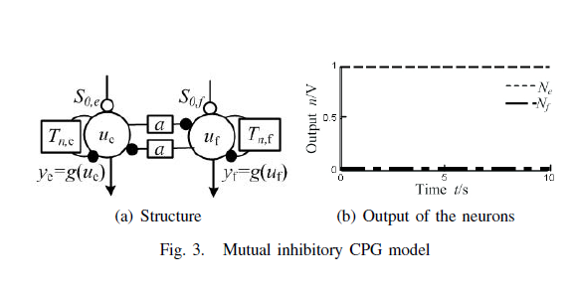  
where *a* is the weight of the mutual inhibitory connection;

*s*0*,e* and *s*0*,f* are constant, positive input, each of which is

the summation of all inputs to *ne* or *nf* by the weight of

synaptic conjunction, excepting the output of the opposite

neuron inner the CPG; *ue* and *uf* are the corresponding

membrance potentials of *ne* and *nf* ; *Tn,e* and *Tn,f* are the

corresponding time constants of *ne* and *nf* ; *ye* and *yf* are the

corresponding output of *ne* and *nf*; and *c out* is the output

of the CPG.  
  
*C. Cyclic Inhibitory CPG Model*

According to the cyclic inhibitory theory, we adopt the

SANs mentioned in section III.A to form a CPG, as shown

in Fig.4. This cyclic inhibitory CPG is composed of *ny* (yaw

neuron), *np* (pitch neuron), and *nm* (modulator neuron). The

dynamics of the cyclic inhibitory CPG is described by the

following equations:

*Tn,*1*u*˙1 + *u*1 = *s*0*,*1 *− ag*(*u*2) (7)

*Tn,*2*u*˙2 + *u*2 = *s*0*,*2 *− ag*(*u*3) (8)

*Tn,*3*u*˙3 + *u*3 = *s*0*,*3 *− ag*(*u*1) (9)

*yi* = *g*(*ui*)*, g*(*ui*) = *max*(0*, ui*) *i* = 1*,* 2*,* 3 (10)  
= *g*(*ui*)*, g*(*ui*) = *max*(0*, ui*) *i* = 1*,* 2*,* 3 (10)

*y out* = *y*1 *− y*3 (11)

*p out* = *y*2 *− y*3 (12)

where *a* is the weight of the cyclic inhibitory connection;

*s*0*,*1*, s*0*,*2 and *s*0*,*3 are constant, positive input, each of which is

the summation of all inputs to *ny*, *np* and *nm* by the weight of

synaptic conjunction, excepting the output of the neurons in

the CPG; *u*1, *u*2 and *u*3 are the corresponding membrance

potential of *ny*, *np* and *nm*; *Tn,*1, *Tn,*2 and *Tn,*3 are the

corresponding time constant of *ny*, *np* and *nm*; *y*1, *y*2 and

*y*3 are the corresponding output of *ny*, *np* and *nm*; *y out* and

*p out* are the corresponding output of the CPG to control the

yaw rotation and pitch rotation.  
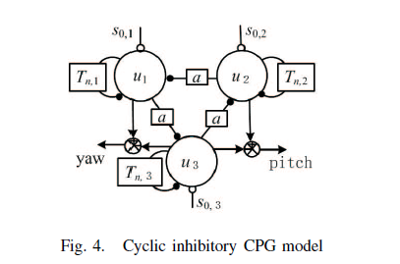  
  
V. COMPUTER SIMULATION

According to the parameters of “Perambulator”, we adopted

ADAMS software to construct a 3D dynamic model of the

snake-like robot. The contact between the robot and the

environment is defined as a coulomb friction. The coefficient

of the static friction is 0.3, and the coefficient of the dynamic  
friction is 0.1. The output of the CPG neuron network was

adopted as the input of the 3D dynamic model of the snakelike

robot. The parameters of the CPG neuron network are

listed in Table III.   
“

**A survey on snake robot modeling and locomotion**

Aksel Andreas Transeth*†*∗, Kristin Ytterstad Pettersen*‡* and

P°al Liljeb¨ack*‡  
„*Snake robots may one day play a crucial role in search

and rescue operations, firefighting, and inspection and

maintenance. The highly articulated body allows the snake

robot to traverse difficult terrains such as collapsed buildings

or the chaotic environment caused by a car collision in

a tunnel. The snake robot could crawl through destroyed

buildings looking for people, while simultaneously bringing

communication equipment together with small amounts of

food and water to anyone trapped in the shattered building.  
  
*2.3.3. Sidewinding locomotion.* Sidewinding is probably the

most astonishing gait to observe and is mostly used by snakes

in the desert. The snake lifts and curves its body leaving short,

parallel marks on the ground while moving at an inclined

angle as shown in Fig. 3. Unlike lateral undulation, there is

a brief static contact between the body of the snake and the

ground.

Sidewinding is usually employed on surfaces with low

shear such as sand. Snakes can reach velocities up to 3 km/h

during sidewinding locomotion.  
 *“*A Survey on Snake Robot Locomotion

G. SEEJA1, AROCKIA SELVAKUMAR AROCKIA DOSS 2, (Senior Member, IEEE),

AND V. BERLIN HENCY 1  
„

The concept of snake robots started in the 1940s. Snake

robots are basically hyper-redundant snake-like biomorphic

mechanisms that mimic the morphology of natural snakes.

A qualitative study on snake locomotion was _rst done by

J. Gray in 1946 [2]. He described the types of movements

snakes possess. Then, Professor Shigeo Hirose developed the

world's _rst snake robot (Figure. 1) at the Tokyo Institute of

Technology, Japan, in 1972 [3]. Since that time, numerous  
The terrain adaptability of snake robots is a highly noticeable

feature that makes them move mostly on surfaces. They use

the ground roughness or obstacles to gain enough friction to

move forward without slipping [7].

Another algorithm known as the Central Pattern Generator

(CPG) [65] allow the robot to avoid obstacles or barriers by

turning the robot body from its trajectory. The CPG model

also allows collision detection using sensory feedback. The

same work also discussed a phase transition method using

a phase difference control parameter to realize the turning

motion. This CPG algorithm based on a neural oscillator is

applied to generate rhythmic rectilinear and lateral undulation

gaits [33].  
„  
  
**Biologically Inspired Snake-like Robots**

Shigeo HIROSE1, Makoto MORI2  
  
„  
Of the characteristics of the

snake family’s mobile body, we may adduce the

following, which depend on the exploitation of a long

and thin, active and flexible, body shape which can

make bending movements:

1. The snake can propel itself over very uneven,

rough ground, or along winding paths by using its

slender body;

2. It is adapted to moving over places where the

surface is not firm, such as marshland or sand

dunes, because it can distribute its weight over its

whole body;

3. Because it normally propels itself in a

kinematically stable posture, it is adapted to

achieve stable movement on irregular terrain,

such as spanning rifts or in trees.  
  
Active Cord Mechanisms are useful for disaster relief

such as searching for survivors of earthquakes through

the debris of collapsed houses. With possibilities to

approach these issues in mind, we developed the new

Active Cord Mechanism “ACM-R3” (**Figure 2**) to be

used easily by snake-like robotics researchers in

several applications [8][10].

“

**Central pattern generators and the control of rhythmic**

**movements**

Eve Marder and Dirk Bucher  
“

*Central pattern generators are neuronal circuits that*

*when activated can produce rhythmic motor patterns*

*such as walking, breathing, flying, and swimming in the*

*absence of sensory or descending inputs that carry*

*specific timing information. General principles of the*

*organization of these circuits and their control by higher*

*brain centers have come from the study of smaller*

*circuits found in invertebrates. Recent work on*

*vertebrates highlights the importance of neuromodulatory*

*control pathways in enabling spinal cord*

*and brain stem circuits to generate meaningful motor*

*patterns. Because rhythmic motor patterns are easily*

*quantified and studied, central pattern generators will*

*provide important testing grounds for understanding*

*the effects of numerous genetic mutations on behavior.*

Sensory input can alter the properties of a

centrally generated motor pattern.

**(a)** Measures used to quantify rhythmic motor  
  
The connectivity diagrams for a number of central pattern

generating networks are becoming known. Although all of

them contain circuit ‘building blocks’ like reciprocal inhibition,

the details of each are different [3,5]. Understanding

the specific dynamics of each network requires determining

the pattern of connectivity, and the intrinsic properties

of the constituent neurons. This approach has been

most successfully carried out in small invertebrate networks,

where the identification of the neurons is relatively

straightforward, and has been more difficult in vertebrate

preparations where identification of neurons and paired

intracellular recordings necessary for the determination of

connectivity are more technically difficult.  
  
**Neuromodulators activate, modify and**

**terminate central pattern generators**

Some central pattern generating circuits operate continuously.

Others are activated to perform specific behavioral

tasks, such as those governing walking, flying and swimming.

As we learn more about the neural and hormonal

control of central pattern generators, we see that they

receive multiple and parallel inputs so that they can be

activated in a number of different fashions. A great deal is

known about the modulatory control of the crustacean

stomatogastric nervous system. The stomatogastric ganglion

receives neuromodulation from three sources (Figure 4a):  
  
Theoretical work has established that the relative strengths

of the descending and ascending coupling pathways are

crucial to segmental coordination [106,108–110]. Therefore,

the details of the coordinating fiber system in each

preparation must be laboriously established with combinations

of anatomical and electrophysiological methods.  
  
“  
  
CPG-based Control of a Simulated Snake-like Robot

Adaptable to Changing Ground Friction

Kousuke Inoue / Takaaki Sumi  
„

Meanwhile, animals adopt decentralized manner to control

their complicated body adapting to changing environments.

Many of voluntary locomotion of animals are rhythmic and

such rhythmic motion pattern is generated and controlled

by CPGs (Central Pattern Generators) distributed in spinal

cord. By feeding back information from peripheral sensors

(such as pressure on skin or length of a muscle) to CPGs,

robustness of locomotion to disturbance is realized [1].

It is natural to consider that living snakes also have CPGs

for locomotion. Recently, some groups including the authors

[10] start studies to control meandering locomotion of snakelike

robots with CPGs [2], [12]. However, previously proposed

models are open-loop, i.e. the models did not have

any sensory feedback information to CPGs, and therefore,

environmental adaptability was not discussed.

The robot has friction force sensors between joints (bottom

of links). Measured values are input to SIN (sensory interneuron).

SIN performs as (1) first-order lag element and (2) dead

time component. (1) is to deal with noise of sensors and (2)

is to add purposive phase-shift to sensory information. The

dynamics of SIN is as follows:

*p*˙ =

1

*τD*

(*St−*Δ*t − p*) (6)

*uL* =

_

*p* (if *p >* 0)

0 (otherwise) (7)

*uR* =

_

0 (if*p >* 0)

*−p* (otherwise) (8)

Δ*t* = *γTt* (0 *< γ ≤* 1) (9)

Output of SIN is fed back to CPG as shown in Fig. 3.  
  
Similarly to the case of Ekeberg’s model, output of 11

oscillators are used as motor control signals. Correspondence

is shown in Table IV.

As the same as in Ekeberg’s model, sensory information is input to SIN and the output of SIN is fed back to CPG.  
  
. In such case, synthetic approach is effective.

We use GA (genetic algorithm) to obtain CPG parameters

that realize adaptive meandering locomotion of the snakerobot.

In order to achieve adaptability, evaluation fuction (fitness

function) is based on performance in different multiple

environments with different friction coefficients.  
„  
  
CPG-based Locomotion Control of a Snake-like Robot for Obstacle

Avoidance

Norzalilah Mohamad Nor1 and Shugen Ma2  
“  
propelling force of the

serpentine motion of a snake-like robot comes from the

interaction of the robot with the ground by swinging the

joints from side to side [1], therefore, it is crucial to control

the joint angle with constant phase difference. The parameter

*ϕ* of the phase oscillator shows a clear relation to the CPG

output [10]. With this property, locomotion of the snake-like

robot in term of its number of *S*-shape can be controlled.

Using the proposed structure of unidirectional coupling, the

total phase difference, *ϕtotal* is given as follows:

*ϕtotal* = *nϕ* (3)

where *n* is the number of actuated joints from head to tail of

the snake-like robot. To get one *S*-shape locomotion, the

“

Design and Analysis of a Snake-Inspired Crawling

Robot Driven by Alterable Angle Scales

Donghua Shen, Qi Zhang , Cunjin Wang, Xingsong Wang , and Mengqian Tian  
„

*A. Scale Friction Characteristic Experiment*

To verify the ability to change the scales’ angle, the angle

variation is tested under different air pressures. In this experiment,

the crawling robot is photographed when the airbag is

inflated at different air pressures, as shown in Fig. 5(A). The

scales’ angle is measured using the photograph obtained above.

Experimental results are shown in Fig. 5(B). It shows that the

scales’ angle gradually decreases as the air pressure in the airbag

increases. The scales will flip to the reverse direction when the

scales’ angle decreases to zero. The reverse turning angle of the

scales reaches its limit and stabilizes at -12*◦* when the airbag’s

air pressure exceeds 24 kPa.  
  
Fig. 7(A) shows the friction between the crawling robot and

the rough surface when the airbag is inflated at different air

pressures. The anchoring coefficient *Cf* can be calculated using

the backward and forward sliding friction, and the results are

shown in Fig. 7(B). It can be observed from the results that

the crawling robot has an optimal anchoring coefficient at a

pressure of 12 kPa. At this pressure, the angle of the scales

is 26.7*◦*. In this state, the crawling robot can crawl forward

more efficiently. When the pressure exceeds 22 kPa, all scales

reverse and the crawling robot crawls backward. The anchoring

coefficient of the reverse crawl can be improved by further

increasing the pressure. The anchoring coefficient cannot be

further improved once the pressure exceeds 26 kPa. Therefore,

the airbag’s air pressures are set at 12 kPa and 26 kPa to obtain

the better crawling capability in the following dynamic crawling

experiments.

“  
  
Design and Control Architecture of a 3D Printed

Modular Snake Robot

Ikram Hussain Mohammed, Nicolas Gallardo, Patrick Benavidez and Mo Jamshidi  
  
“  
III. DESIGN

Each module of the 3D printed modular snake robot functions

as single rotational joint with one Degree of Freedom

(DOF). Every module is able to rotate 90 degrees with respect

to previous module, thus enabling the generation of movement

utilizing many different methods. Each module is connected

to the previous module in such a way that the axis of rotation

is perpendicular with respect to previous one. Having two

different axis of movement in each segment pair, means that

the robot is able to generate movement in all three axis given

at least four segments in the chain. In other words, the modules

allow for movement in both the vertical and horizontal axis,

thus enabling the robot to move in a three dimensional plane.  
  
“  
  
Design and Control of Biologically Inspired Wheel-less

Snake-like Robot*  
  
„  
*D. Biologically inspired generation of propulsive forces*

Let us now consider a 5-link mechanism in

simultaneous contact with three push-points **PP1**, **PP2** and

**PP3** as shown in Fig. 6. At this stage, we have to determine

an appropriate vector of motor inputs which would

make the mechanism mimic the natural snake motion. We

know by far that every module has to follow its

predecessor, as illustrated in Table I.  
At this end, the first joint is actuated to make the head

module push against the corresponding push-point. The

following joints are actuated so that each module orientation

evolves toward its desired value. Instantaneously required

control inputs are illustrated in Fig. 6.

Finally, the orientation of the sum of the reaction forces

*i R*

􀁇

along the mechanism gives the global progression

direction, in accordance with the lateral undulation observed

in natural snakes. Results of the experiments with the above

mentioned control are discussed in the next sections.  
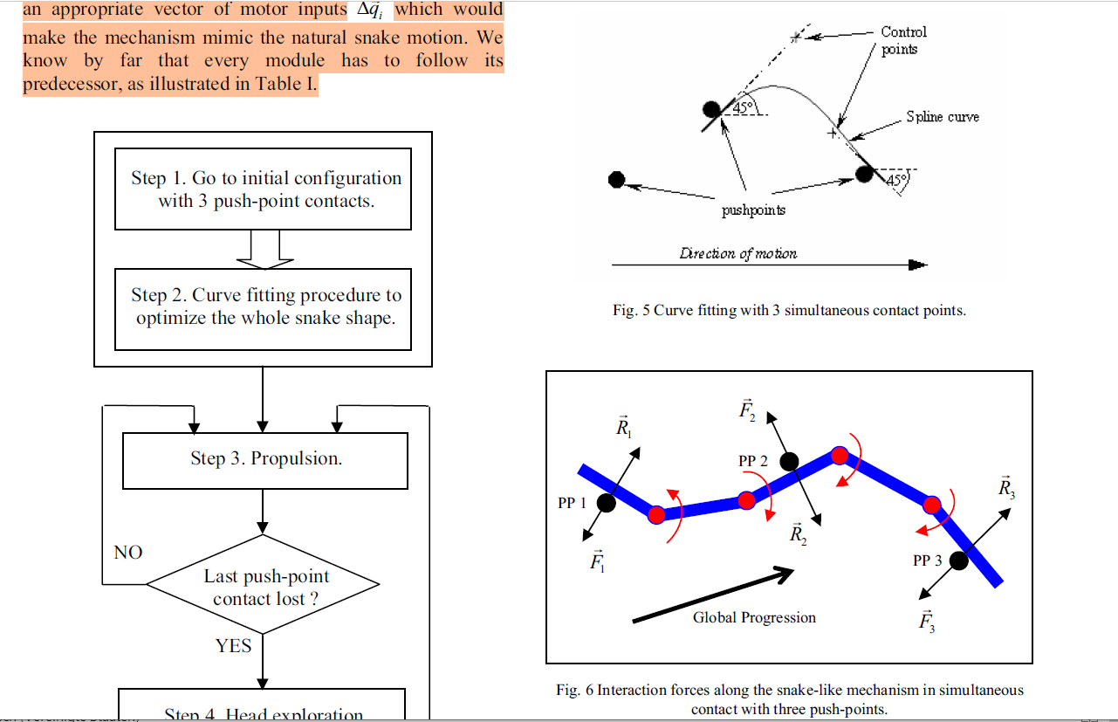  
*A. Experiments*

Experiments have been carried out by closed-loop

control of the snake-like locomotion through lateral

undulation. The main result is that the physical phenomena

observed with natural lateral undulation have been

reproduced with a wheel-less snake-like mechanism with a

relatively restricted number of DOF and a simple

mechanical structure. The present approach has been based

on biological inspiration, which guided the design and  
  
„

Design of a CPG-Based Close-Loop Direction

Control System for Lateral Undulation Gait of

Snake-Like Robots

Quan Minh Dao, Quan Tuong Vo  
“  
II. DESIGN OF THE CPGS NETWORK

A. Mathematical Equations and structure of the network

Taking the inspiration of CPGs networks design in [3], [5]

we first use the single chain bidirectional coupling network

described in Fig.1. In this figure, an arrow represents a

connection which goes from the CPG at its origin to the one

at its tip. The value written on the connection which is either

' or 􀀀' informs the phase lag between these two CPGs. The

differential equations system describing the whole network is

__k =

8>>><

>>>:

2_v + w sin(_2 􀀀 _1 + '); k = 1

2_v + w

"

sin(_k􀀀1 􀀀 _k 􀀀 ')+

+sin(_k+1 􀀀 _k + ')

#

; 2 _ k _ N 􀀀 1

2_v + w sin(_N􀀀1 􀀀 _N 􀀀 '); k = N

(1)

_k = Acos(_k); 1 _ k _ N (2)

Here, v is the intrinsic frequency parameter, while w is the

coupling strength of connections in the network. These two

parameters are positive and constant. _k; __k; _k are respectively

the state variable, its first-order time derivative, and the

output of the kth CPG in the network of N CPGs. _k is then

used as reference signal of angular position of snake robot kth

joint. A is the amplitude of oscillation.

As mention in section I, the S-shape motion of snake-like

robots is created by rhythmic oscillation among robot joints

,i.e. every joint oscillates with the same frequency and constant

phase shift. In other words, the system of (1) and (2) must  
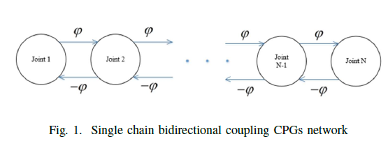  
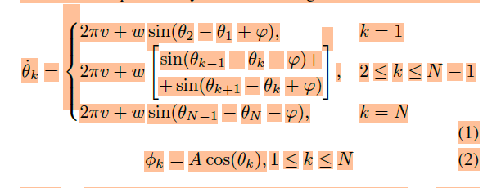  
  
  
“  
Efficient rolling motion for snake-like robots utilizing center of gravity shift✩

Akio Yamano ∗, Yuuki Ikeda, Keita Imai, Masakatsu Chiba  
“  
*3.2. Rolling motion with the COG shift*

We propose the rolling motion with a COG shift as more efficient

motion than other locomotions.

Fig. 5 demonstrates the proposed rolling motion with the COG shift.

Fig. 5(a) illustrates the procedure of the rolling motion. The procedure

of this motion is divided into four stages as follows:

[Step 1] Kick stage: The head or tail section is moved to kick the

ground, to generate the rolling motion.

[Step 2] COG shift stage I: A heavier head or tail link is moved forward

to move the COG forward.

[Step 3] COG shift stage II: A heavier head or tail link is moved above

to move the COG forward.

[Step 4] Rolling stage: Rolling motion is generated by gravity.  
  
  
“

Frictional Properties of a Novel Artificial Snakeskin for Soft Robotics Frederik Lamping a,*, Stanislav N. Gorb b, Kristin M. de Payrebrune a   
  
“

1. **Introduction** Although limbless, the locomotion of snakes is versatile. Besides four common gaits when moving on the ground [1], snakes are capable to swim, to climb trees, and to grasp objects. This versatility might be a reason why the investigation of the locomotion of snakes has attracted researchers in the past, like Shigeo Hirose in 1976 [2], and continues to do so today. Recent research addresses several aspects of the snakes’ locomotion, like the biomechanics [3,4], the friction anisotropy [5,6], the motion of the scales [7], and their surface microstructure [8]. A comprehensive summary of the latest findings is given in [1]. Not only the investigation of snakes is of interest to researchers, but also the bio-inspired design of snake-like robots. Although snake-like robots are not common in everyday use, new designs are continuously being developed. A review of older designs is given in [9], while [10] enlightens the state of the art of the modeling of snake-like robots.  
     
   “

Lateral undulation of snake robots: A simplified model and fundamental

properties

1. Article *in* Robotica · October 2013

“

Abstract

This paper considers lateral undulation motion of snake robots. The first contribution of the paper is

a model of lateral undulation dynamics developed for control design and stability analysis purposes. The

second contribution is an analysis of the simplified model that shows that any asymptotically stabilizing

control law for the snake robot to an equilibrium point must be time-varying. Furthermore, the analysis

shows that a snake robot (with four links) is strongly accessible from almost any equilibrium point,

except for certain singular configurations, and that the robot does not satisfy sufficient conditions for

small-time local controllability (STLC). The third contribution is based on using averaging theory to

prove that the average velocity of the robot during lateral undulation will converge exponentially fast

to a steady state velocity which is given analytically as a function of the gait pattern parameters. From

the averaging analysis, we also derive a set of fundamental relationships between the gait parameters of

lateral undulation and the resulting forward velocity of the snake robot. The paper presents simulation

results and results from experiments with a physical snake robot that support the theoretical findings.  
  
I. INTRODUCTION

Inspired by biological snake locomotion, snake robots carry the potential of meeting the growing need

for robotic mobility in unknown and challenging environments. These mechanisms typically consist of

serially connected joint modules capable of bending in one or more planes. The many degrees of freedom  
  
of snake robots make them difficult to control, but provide traversability in irregular environments that

surpasses the mobility of the more conventional wheeled, tracked and legged forms of robotic mobility.  
  
III. THE GAIT PATTERN LATERAL UNDULATION

Lateral undulation, also called serpentine crawling, is the fastest and most common form of snake

locomotion. During lateral undulation, continuous horizontal waves are propagated backwards along the

snake body from head to tail. The body waves produce interaction forces between the snake body and

irregularities in the surface that push the snake forward. As proposed by Hirose2, lateral undulation is

achieved by controlling joint i 2 f1; _ _ _ ;N 􀀀 1g of the snake robot according to the sinusoidal reference

_i;ref = _ sin (!t + (i 􀀀 1) _) + _o  
  
“

Locomotion of a Snake-like Robot Controlled by the

Bidirectional Cyclic Inhibitory CPG Model*∗*

Zhenli Lu1*,*3*,*4 Shugen Ma1*,*2 Bin Li1 Yuechao Wang1  
  
„  
In serpentine locomotion, the snake pushes against the

ground on the back side of each curve or undulation and

flows smoothly forwards. It is the result of the hemispherical

condyles on the back of the vertebrae swayed only in the

horizontal plan. In rectilinear locomotion, the skin of the

ventral surface is moved forwards and backwards by strong

muscles, and the broad belly scales grip the ground, moving

the snake forwards in a straight line. It is used only by

the heavier-bodied snakes, so we do not consider it here.

In concertina locomotion, the body is alternately stretched

out and pulled together as the snake moves from one anchor

point to another. It is used in crossing smooth surfaces and

in climbing. It is the result of the hemispherical condyles on

the back of the vertebrae swayed only in the vertical plan.

Several desert-dwelling species use sidewinding to move on

loose sand. In this method the snake throws its body sideways

along the ground in a looping motion. It is the result of the

hemispherical condyles on the back of the vertebrae swayed

in 3D plan. Actually the ribs do not move forwards and

backwards in any of the four types of movements.Muscles are

versatile motors. They can pull against each other and against  
  
the CPG can generate the corresponding rhythmic

pattern for the serpentine locomotion, concertina locomotion

and side winding locomotion. Feedback from the Central

Pattern Generator directed to the higher level control neurons,

the feedback from the effector organs to the CPG, and the

feedback from the environment to either the CPG or to high

level neuron. The feedback signals modify the locomotion

pattern and are fundamental to achieve good performance

by the whole control system in real environment.

IV. ANALYSIS OF MECHANISM FOR RHYTHM GENERATION

Before analyzing the stability of the stationary states we

specify a theorem on the existence, uniqueness and boundedness

of the solution of (1), (2).

Theorem 1. A solution of Eq.(1), (2) exists uniquely for

any initial state and is bounded for *t ≥* 0.

„  
  
Serpentine and Rectilinear Motion Generation in Snake Robot Using

Central Pattern Generator with Gait Transition

Sajjad Manzoor1

• Uzair Khan2

• Ihsan Ullah2  
  
“

a CPG can be formed by Kuramoto oscillator (Sksguchi

and Kuramoto 1986) [which was further extended in

Ijspeert et al. (2007)]. This oscillator is combined with two

first-order radial functions. The proposed central pattern

generator consists of coupled neural oscillators with a

excitatory neuron and inhibitory neuron for each wheellink.  
  
  
This function generates continuous sinusoidal firing for

serpentine motion and a neuron firing with recovery period

for rectilinear motion. aj and bj adjusts the recovery period,

amplitude and rise time of neuron output. For the serpentine

locomotion we take aj ¼ 1 and bj ¼ 0 and for the case

of rectilinear motion we take aj ¼ bj þ 6 and bj ¼ 40. In

order to get smooth transaction between different types of

snake robot motion the phase difference /j;k is taken as a

function of parameter ‘‘s’’ as follows:

Uj;k ¼ Uj;kð0ÞðS _ sÞ þ Uj;k _ Uj;kð0Þ _ _ðs _ sð0ÞÞ ð10Þ

where Uj;kð0Þ is phase difference at the start of each transition

and Uj;k is the required phase difference between jth

and kth neuron in each of serpentine and rectilinear motion

in the neural oscillator. On the other hand, s(0) ) is the starting value of parameter s.  
  
“

Soft Robotic Snake Locomotion: Modeling and Experimental

Assessment

Dimuthu D. K. Arachchige1, Yue Chen2, and Isuru S. Godage1  
  
„  
Abstract—Snakes are a remarkable evolutionary success

story. Numerous snake-inspired robots have been proposed over

the years. Soft robotic snakes (SRS), with their continuous and

smooth bending capability, can better mimic their biological

counterparts’ unique characteristics. Prior SRSs are limited

to planar operation with a limited number of planar gaits.

We propose a novel SRS with spatial bending ability and

investigate snake locomotion gaits beyond the planar gaits of

the state-of-the-art systems. We derive a complete floating-base

kinematic model of the SRS and use the model to derive jointspace

trajectories for serpentine and inward/outward rolling

locomotion gaits. These gaits are experimentally validated

under varying frequency and amplitude of gait cycles. The

results qualitatively and quantitatively validate the proposed

SRSs’ ability to leverage spatial bending to achieve locomotion

gaits not possible with current SRS designs.  
  
  
„